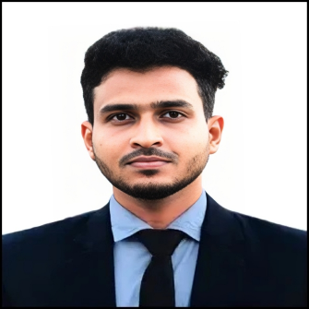

**Md. Minhajul Abedin**

Bongaon, Bongaon Hat, Haripur, Thakurgaon

**Contact:** +8801774474234

**Email: eco1803011brur@gmail.com**

**Career Objective:**

Leverage my academic background in Economics and proven leadership experience to drive operational excellence and community impact as an Assistant Branch Manager at BURO Bangladesh. Committed to promoting financial inclusion and empowering communities by delivering innovative solutions and ensuring sustainable growth.

**Educational Qualifications:**

|  |  |  |  |  |
| --- | --- | --- | --- | --- |
| **Degree** | **Major/Group** | **Institution** | **Result** | **Year** |
| Master of Social Science | Economics | Begum Rokeya University, Rangpur | On Going |  |
| Bachelor of Social Science (BSS) | Economics | Begum Rokeya University, Rangpur | 3.40 | 2022 |
| Higher Secondary Certificate (HSC) | Science | Rani Sonkail College | 4.17 out of 5.00 | 2018 |
| Secondary School Certificate (SSC) | Science | Bongaon High School | 4.56 out of 5.00 | 2016 |

**Extra-Curricular Activities:**

**President,** 2023-till now, Career and Skill Development Club Department of Economics ,Begum Rokeya University, Rangpur

* **Leadership and Development:** employability and foster their professional growth through targeted programs and skill-building activities
* **Collaboration and Impact:** **Collaborate** with cross-functional teams, **leverage** leadership and analytical skills, and **drive** community empowerment through innovative financial services and economic initiatives.

**Executive member**, 2023-till now, Economics Student Association, Department of Economics

,Begum Rokeya University ,Rangpur

* **Event Planning and Coordination:** Organize seminars, workshops, and academic events to promote economic literacy and professional development among students.
* **Collaboration with Clubs and Organizations:** **Collaborate** with other university clubs and associations to **plan** joint activities and **promote** interdisciplinary learning and networking opportunities.
* **Leadership and Representation:** Represent the Economics Department in university-wide forums, collaborating with faculty and students to address academic and extracurricular concerns.
* **Student Engagement:** Facilitate student participation in academic competitions, career fairs, and skill development programs, fostering an active and engaged student community.

**Vice-president** , 2023- till now, Thakurgaon Kollan Somity,Begum Rokeya University, Rangpur

* **Assist, Facilitate**
* **Coordinate, Lead**

**Volunteer,** Annual literature, Culture and indoor sports competition-2023,Department of Economics,Begum Rokeya university,Rangpur.

**Training and Workshop:**

* 1 day **“R Programming”** workshopatResearch, Seminar and workshop club of department of Economics, Begum Rokeya University, Rangpur. (7 May-7 May 2024)
* 4 days **“Job Readiness Traning”** at Career Hub, Powered by BRAC Skills Development Programme ( 9 September-12 September)

**Skills:**

* Communication
* Teamwork
* Leadership
* Adaptability
* Volunteerism
* Analytical Skills
* Public Speaking
* Digital Skills: MS Word,

MS PowerPoint,

MS Excel,

R Programming,

STATA ,

SPSS

**Personal Details:**

**Father’s Name:** Md. Abdul Kader

**Mother’s Name:** Most. Nargis Akter

**Date of Birth:** 24 December, 2000

**NID Number:** 8261871928

**Parmanent Address:** Word No-09, Village: Bongaon, Post Office: Bongaon Hat ,Thana: Haripur, District: Thakurgaon

**Reference:**

Md. Belal Uddin

Associate Professor

Department of Economics

Begum Rokeya University, Rangpur

Contact: +8801722845715

Email: belal.eco@brur.ac.bd

Kazi Newaz Mostafa

Assistant Professor

Department of Economics

Begum Rokeya University, Rangpur

Contact: +8801720214411

Email: knm.eco@brur.ac.bd

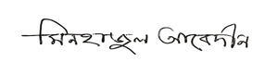

**Signature**